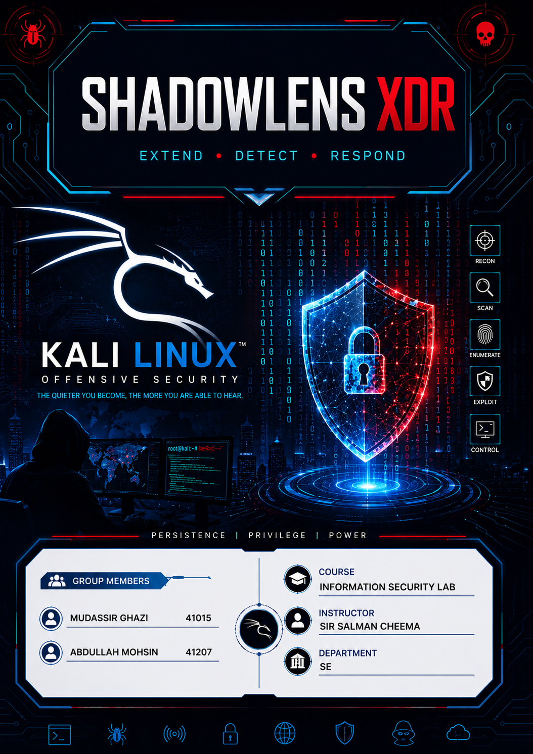

Table of Contents
1. PROJECT BACKGROUND 3
2. PROBLEM STATEMENT 3
3. OBJECTIVES 4
4. RELATED SYSTEMS (LITERATURE REVIEW) 5
5. METHODOLOGY AND WORKFLOW 6
6. ALGORITHM AND PSEUDOCODE 10
7. INSTALLATION PROCESS STEP BY STEP 11
7.1 Step 1 11
Extracting the Tool 11
7.2 Step 2 12
Running the Installer Script 12
7.3 Step 3 13
System Package Installation 13
7.4 Step 4 14
Python Dependency Installation 14
7.5 Step 5 15
Final Setup and Confirmation 15
8. IMPLEMENTATION AND TESTING 16
9. RESULTS SUMMARY TABLE 24

1. PROJECT BACKGROUND
In today's digital threat landscape, cybersecurity analysts face a growing challenge: the sheer volume and variety of file-based attacks has exploded. Malicious actors embed threats inside everyday files PDFs, Word documents, emails, ZIP archives, and images exploiting the trust users place in familiar formats.
Traditional security tools were built for a simpler era. Antivirus software checks file signatures. Sandbox environments detonate suspicious files in isolation. OSINT platforms look up URLs. Metadata analyzers inspect document properties. Each tool does one job well, but none of them talk to each other.
The result is that a security analyst investigating a suspicious PDF must open four or five different tools, manually correlate their outputs, write notes, and form a judgment. This process is slow, error-prone, and mentally exhausting, especially under the pressure of a live incident.
ShadowLens XDR was conceived to solve this fragmentation problem. The idea is straightforward: take all the detection capabilities that analysts already rely on and unify them under a single intelligent scanning engine, so a single file scan produces one consolidated, easy-to-read threat report instead of five scattered ones.
The name "ShadowLens" reflects the tool's purpose: shining light into the hidden, obfuscated, and deceptive corners of files that attackers rely on staying dark. XDR stands for Extended Detection and Response, an industry-standard cybersecurity term describing tools that correlate signals across multiple data sources rather than monitoring just one the same underlying philosophy used by enterprise products such as Microsoft Defender XDR, Cortex XDR, and CrowdStrike Falcon XDR, scaled down here into a lightweight, file-focused forensic tool.

2. PROBLEM STATEMENT
Security analysts today suffer from what the industry calls "tool sprawl." When a suspicious file arrives, the typical manual workflow looks like this: run ExifTool for metadata, then VirusTotal for reputation, then a URL extractor for embedded links, then a phishing keyword checker, then manually inspect the raw file structure for hidden objects. Each step requires switching applications, copying and pasting results between them, and mentally correlating the findings.
This fragmented workflow creates three serious, well-documented problems.
First, speed loss. A file that could be triaged in under a minute with a unified tool instead takes ten to fifteen minutes because the analyst is juggling multiple separate applications. In active incident response, every minute of delay matters.
Second, coverage gaps. When findings are stitched together manually, correlations get missed. A URL that looks harmless in isolation may be highly suspicious when combined with the fact that the same document also contains hidden high-entropy data and manipulated metadata. No single standalone tool sees that combination only a human analyst piecing it together by hand, which is slow and inconsistent between analysts.
Third, skill dependency. Junior analysts may not know which tool to reach for or how to interpret five different outputs together. The correlation knowledge lives in a senior analyst's head, not in any toolchain, which makes the organization dependent on specific people rather than a repeatable process.
ShadowLens XDR addresses all three problems directly by providing one command, one scan, and one consolidated risk report covering every angle at once.

3. OBJECTIVES
The primary objective of this project is to design and build a lightweight, Kali Linux compatible forensic analysis tool that accepts any file as input and produces a complete, scored threat-intelligence report as output, without depending on paid or proprietary services.
The specific objectives are as follows:
Objective 1
Perform multi-layer file analysis covering metadata extraction, URL and link extraction with reputation checking, hidden-content detection via entropy analysis, phishing and social-engineering indicator detection, obfuscation and encoding detection (Base64, hex, PowerShell encoded commands), archive inspection for nested malicious content, and email/attachment analysis.
Objective 2
Produce a single unified risk score from 0 to 100, with a clear severity label of Clean, Low, Medium, High, or Critical, calculated from weighted detection signals collected across every module.
Objective 3
Generate a structured forensic report, viewable directly in the terminal and optionally exportable as a plain-text or JSON file for record-keeping.
Objective 4
Ensure the entire tool is installable on a standard Kali Linux system using open-source dependencies only, with no commercial licenses or paid API keys required for core functionality.
Objective 5
Validate the tool's accuracy by testing it against both safe, self-created synthetic files and a real-world malware sample obtained from a legitimate research repository, confirming the detection logic and risk-scoring engine behave correctly in both controlled and real conditions.

4. RELATED SYSTEMS (LITERATURE REVIEW)
Several existing tools already address individual pieces of the problem ShadowLens XDR is trying to solve as a whole. Reviewing them clarifies exactly what gap this project fills.
ExifTool, created by Phil Harvey, is the long-standing gold standard for metadata extraction. It reads hundreds of file formats and surfaces creation dates, author names, GPS coordinates, software versions, and editing history. However, it does nothing beyond metadata — it has no URL checking, no phishing detection, no risk scoring, and no broader correlation across other signal types. It is a powerful component, not a platform.
VirusTotal is the most widely used file and URL reputation service in the world, aggregating verdicts from over seventy antivirus engines. Its limitations are that it requires internet connectivity and an API key, enforces strict rate limits on its free tier, and produces only a pass/fail verdict without explaining the underlying forensic reasoning. It also performs no analysis of hidden content, metadata abuse, or social-engineering language.
FOCA (Fingerprinting Organizations with Collected Archives) is a Windows-based tool focused on metadata extraction from documents for OSINT and reconnaissance purposes. It is effective at surfacing organizational information leaked in document properties, but it is not a threat-detection tool, it runs only on Windows, and it is no longer actively maintained.
pdfid and pdf-parser, written by Didier Stevens, are widely respected Python tools built specifically for PDF structural analysis. They detect dangerous PDF elements such as embedded JavaScript, embedded files, and launch actions extremely well, but they are PDF-only, have no built-in scoring system, and produce raw technical output that requires an experienced analyst to interpret correctly.
PhishTank and OpenPhish are community-maintained databases of known phishing URLs. They are useful for reputation lookups against already-reported threats but are inherently reactive they can only identify URLs that have already been reported by someone else, and cannot detect a brand-new phishing page through behavioral or linguistic indicators alone.
The clear gap across all of these tools is the absence of a single, unified, multi-format platform that combines metadata analysis, content inspection, URL reputation, phishing detection, and obfuscation analysis into one coherent scan with one final risk score. ShadowLens XDR is designed specifically to fill that gap, drawing on the proven techniques each of these specialized tools already uses, but running them together automatically instead of one at a time by hand.

5. METHODOLOGY AND WORKFLOW
The ShadowLens XDR architecture is built around a pipeline model. Every file submitted to the tool passes through the same sequence of stages regardless of its type, with type-specific modules activating automatically once the file format is identified.
Stage 1
File Ingestion and Type Detection. The tool reads the first bytes of the file and compares them against a table of known magic-byte signatures (PDF, ZIP, OLE, PNG, JPEG, ELF, PE-EXE, RAR, 7Z, GZIP, and more) to determine the file's true type regardless of its extension. This step alone defeats a common attacker trick of disguising one file type as another simply by renaming the extension.
Stage 2 Universal Modules. These three modules run on every file no matter what type it is.
- The Metadata Module extracts author, software, creation/modification dates, and flags anomalies such as future-dated timestamps or known malicious-tool signatures.
- The Entropy Module calculates Shannon entropy across the file in chunks, flagging unusually random-looking regions that may indicate hidden encrypted or compressed payloads.
- The String Extraction Module pulls every readable ASCII and Unicode string out of the raw bytes, then parses those strings for URLs, IP addresses, email addresses, and known threat-related keywords.
Stage 3
Format-Specific Modules. Based on the type identified in Stage 1, exactly one specialized module activates: the PDF module looks for dangerous objects like JavaScript, OpenAction, and embedded files; the Office module checks for VBA macros, DDE injection, and suspicious external relationships; the Email module verifies SPF/DKIM headers and checks for sender spoofing; the Archive module checks for password protection, path traversal, and ZIP bombs; and the Image module checks for steganography indicators and data hidden after the image's end marker.
Stage 4
URL Reputation Engine. Every URL extracted in earlier stages is deduplicated and checked against suspicious top-level domains, known shortener services, common typosquatting patterns, live DNS resolution, and optionally, if an API key is supplied VirusTotal's reputation database.
Stage 5
Phishing and Social Engineering Detection. The tool scans all extracted text for urgency language ("verify your account immediately"), brand impersonation, credential-harvesting phrases, and Unicode homograph characters used to disguise lookalike domains.
Stage 6
Obfuscation Detection. All extracted strings are scanned for Base64 and hex-encoded blocks, which are automatically decoded and inspected for embedded executable signatures (such as the Windows "MZ" header), as well as for PowerShell -EncodedCommand patterns commonly used in living-off-the-land attacks.
Stage 7
Risk Score Calculation. Every finding from every module is combined using a severity-weighted formula, then compressed through a sigmoid function so that no single finding and no flood of trivial findings can unfairly dominate the final score. The result is a single number from 0 to 100, labeled Clean, Low, Medium, High, or Critical.
Stage 8
Report Generation. A color-coded terminal report is printed showing the risk gauge, every individual finding grouped by severity, a per-module score breakdown, and a complete IOC (Indicator of Compromise) list of every URL, IP address, and email address found with an option to additionally save the full report as a .txt or .json file for record-keeping.

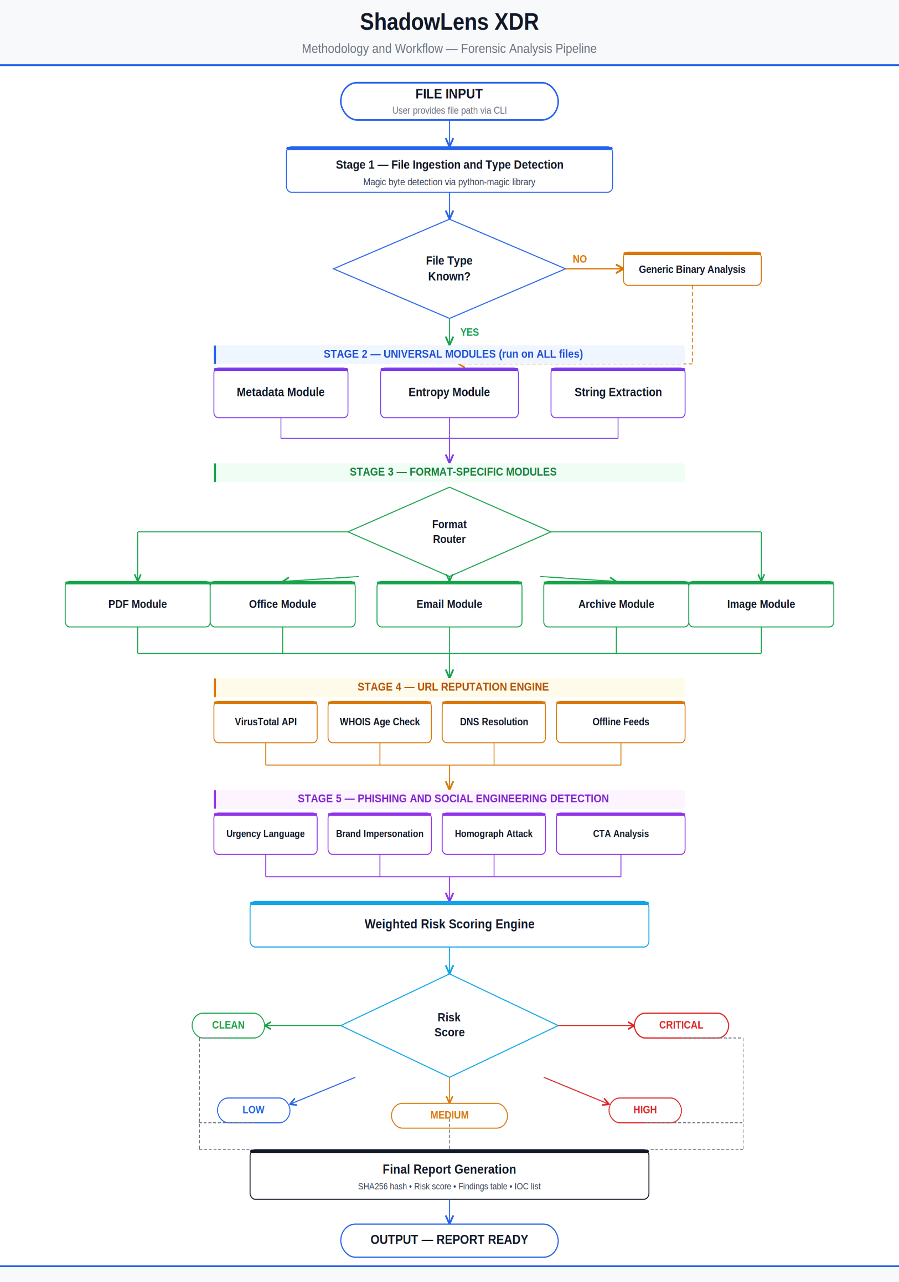

6. ALGORITHM AND PSEUDOCODE
FUNCTION shadowlens_scan(file_path):
file_info = detect_file_type(file_path)
file_hash = compute_sha256(file_path)
findings = []
metadata_results = run_metadata_module(file_path)
entropy_results = run_entropy_module(file_path)
strings, urls, ips, emails = extract_strings(file_path)
findings += metadata_results + entropy_results
IF file_info.type == "PDF":
findings += run_pdf_module(file_path)
ELSE IF file_info.type == "OFFICE":
findings += run_office_module(file_path)
ELSE IF file_info.type == "EMAIL":
findings += run_email_module(file_path)
ELSE IF file_info.type == "ARCHIVE":
findings += run_archive_module(file_path)
ELSE IF file_info.type == "IMAGE":
findings += run_image_module(file_path)
findings += detect_obfuscation(strings)
findings += detect_phishing(strings, urls)
FOR each url IN urls:
findings += check_url_reputation(url)
raw_score = SUM(finding.weight * severity_multiplier(finding.severity))
final_score = sigmoid_compress(raw_score)
label = classify(final_score) // Clean / Low / Medium / High / Critical
report = generate_report(file_hash, findings, final_score, label)
RETURN report
END FUNCTION

Severity weight table (representative values): dangerous PDF object = 20–30, embedded executable = 35–40, obfuscated payload = 15–28, malicious URL confirmed via VirusTotal = 40, phishing keyword = 12–22, suspicious metadata anomaly = 8–25, high-entropy region = 15–20, password-protected archive = 20, path-traversal filename = 35.
Severity multipliers used in the scoring formula: CRITICAL = 1.5, HIGH = 1.0, MEDIUM = 0.6, LOW = 0.3, INFO = 0.0. The raw weighted sum is passed through a sigmoid compression function so that a single critical finding does not unfairly dominate the entire score, while several minor, low-weight findings cannot inflate the score beyond what is actually justified by the evidence.

7. INSTALLATION PROCESS STEP BY STEP
Before any testing could be performed, ShadowLens XDR had to be deployed on a real Kali Linux system. To keep the entire project safe especially the later phase involving a genuine malware sample every step was carried out inside an isolated virtual machine running in Oracle VirtualBox, never on the host computer directly. This is standard, mandatory practice for any kind of malware-related testing.

7.1 Step 1

Extracting the Tool
The ShadowLens XDR ZIP package was placed in the Downloads folder and extracted with the standard unzip command.
Commands used:
cd /home/kali/Downloads
unzip ShadowLens_XDR.zip
cd shadowlens

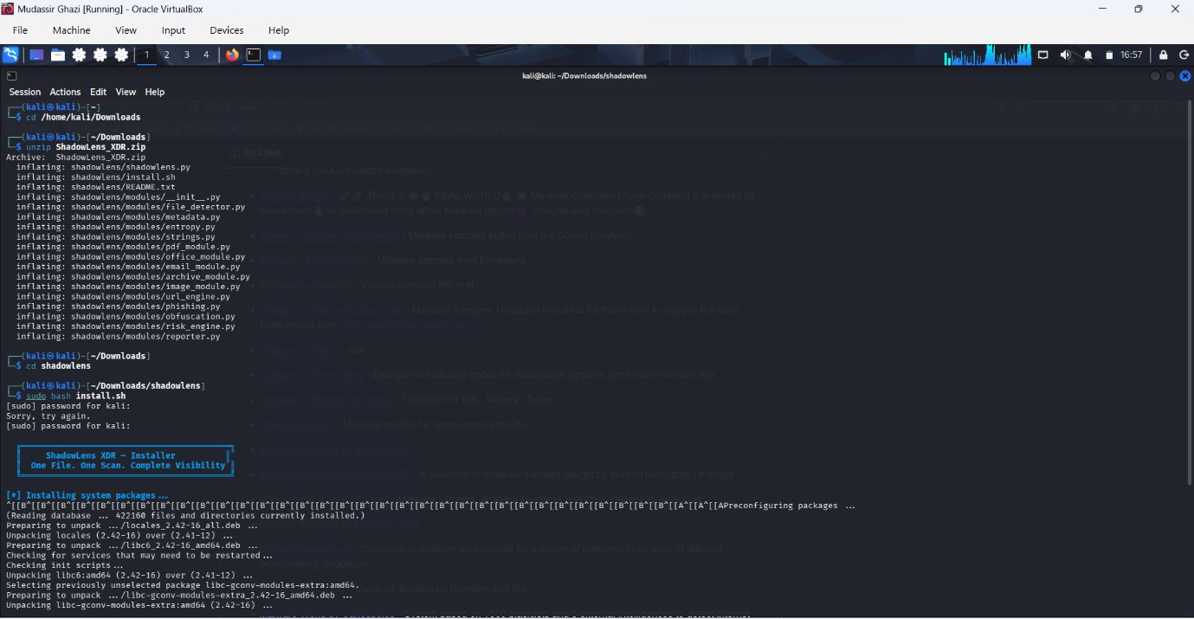

This confirmed the package structure was complete and uncorrupted before installation began.

7.2 Step 2

Running the Installer Script
The bundled install.sh script automates every dependency installation step. Because it installs system-level packages through apt, it must be run with root privileges using sudo.
Command used:
sudo bash install.sh
On the first attempt, the sudo password was entered incorrectly, producing a "Sorry, try again" prompt before the correct password was accepted on the next try — a normal, harmless occurrence when typing a hidden password field.

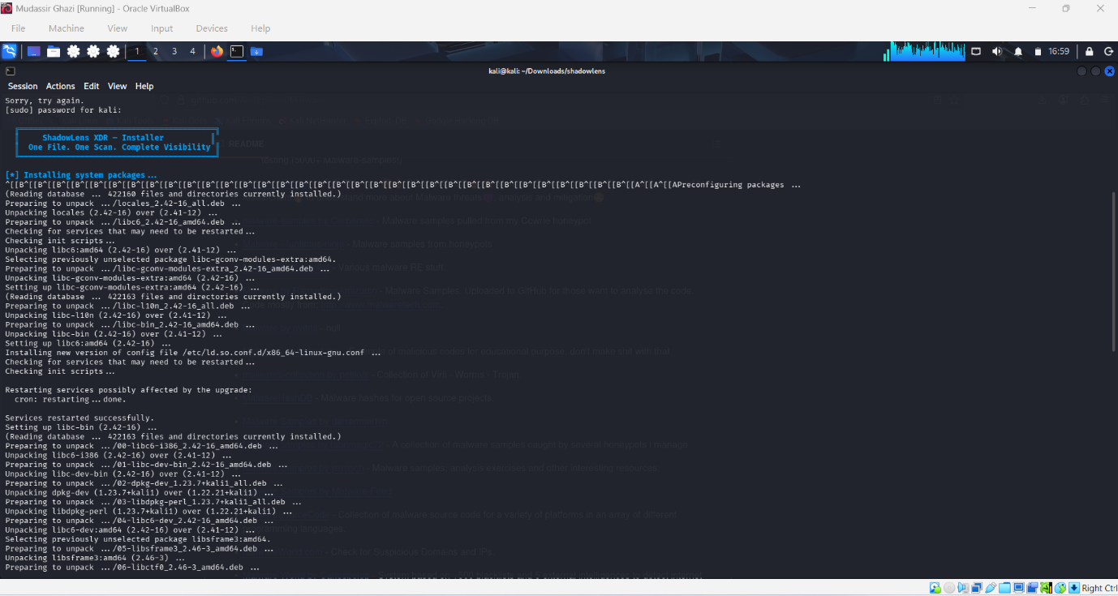

7.3 Step 3

System Package Installation
Once authenticated, the script proceeded to update package lists and install the required system tools: ExifTool (libimage-exiftool-perl) for metadata extraction, p7zip-full and unrar for archive analysis, and supporting libraries such as libmagic for file-type detection.
What the script ran internally:
apt-get update -qq
apt-get install -y libimage-exiftool-perl p7zip-full unrar binutils file
During this phase, the Debian package manager displayed its standard unpacking and configuration sequence for each dependency, including locale generation and a one-time interactive prompt asking whether system services should restart automatically during future library upgrades.

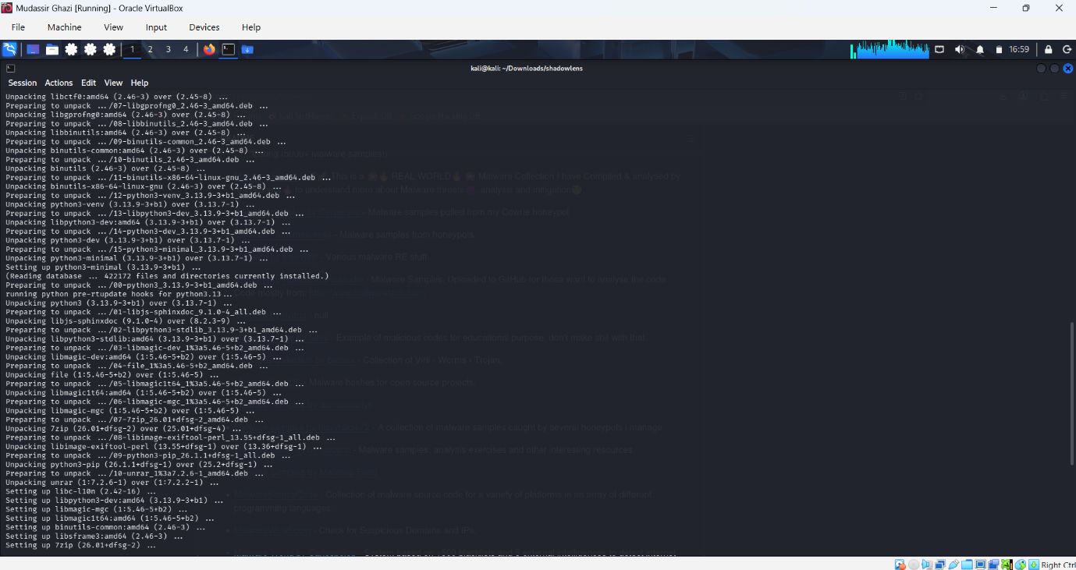

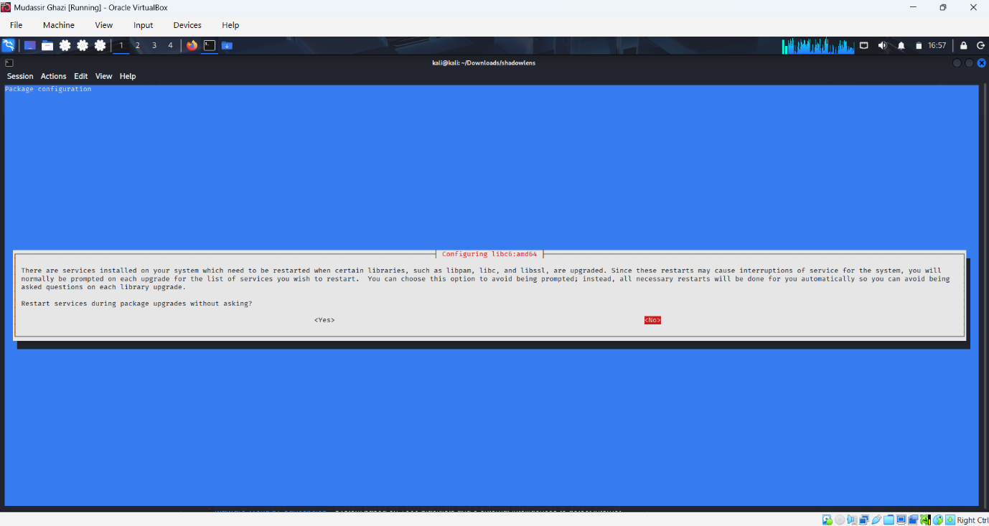

7.4 Step 4

Python Dependency Installation
After the system packages finished installing, the script moved on to installing the required Python libraries (python-magic, requests, python-whois) using pip3 with the --break-system-packages flag, which is required on newer Kali releases that protect the system Python environment by default.
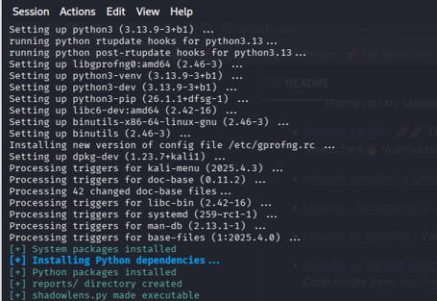

7.5 Step 5

Final Setup and Confirmation
In its last phase, the installer created the reports/ output directory, made shadowlens.py executable, and offered to add a convenient global shadowlens alias to the shell configuration file so the tool could be run from anywhere without typing the full path.
Prompt encountered:
[?] Create global alias 'shadowlens'? (y/n)
y
[+] Alias added to ~/.bashrc — restart terminal or run: source ~/.bashrc

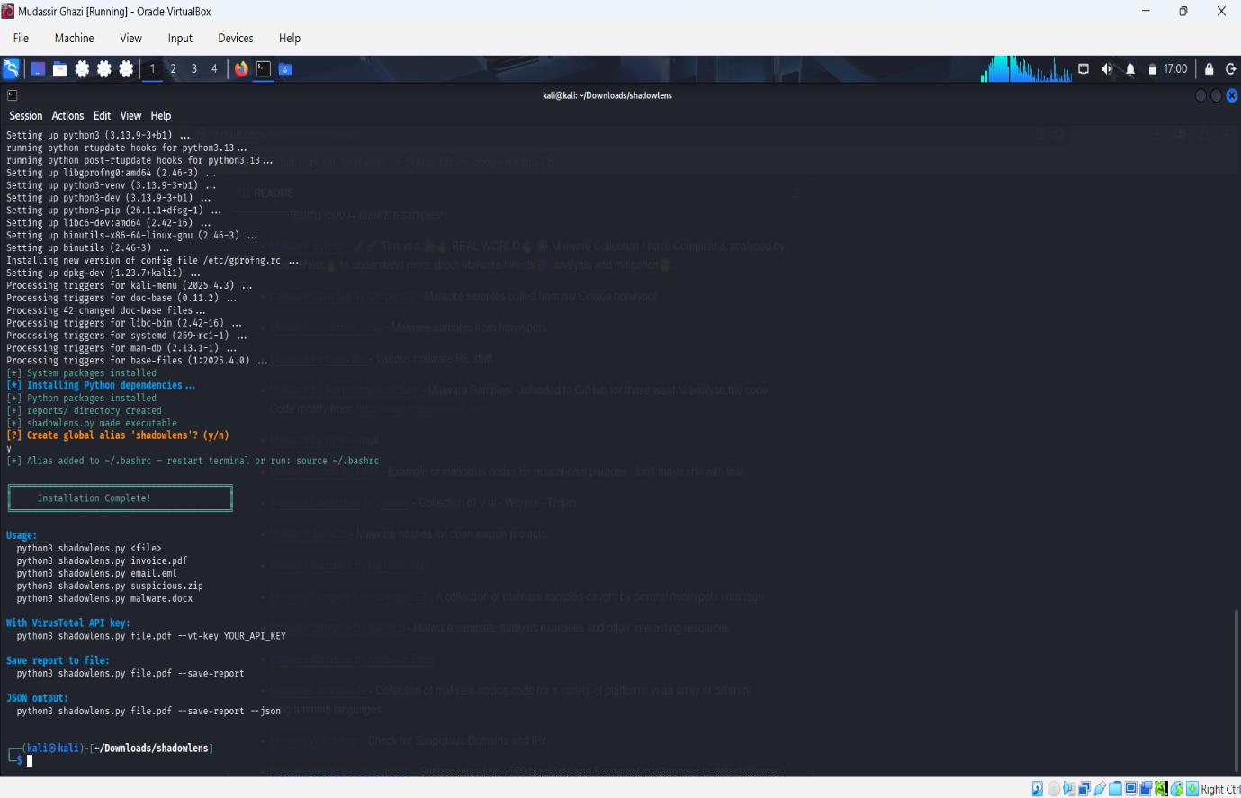
At this point, ShadowLens XDR was fully installed and ready to scan files, confirmed by the tool successfully responding to python3 shadowlens.py --help in the terminal.

8. IMPLEMENTATION AND TESTING
With installation complete, the tool was tested in two stages on a real, isolated Kali Linux virtual machine: first against a self-created, everyday PDF document to confirm normal behavior on safe files, and then against a genuine malware sample obtained from a legitimate research repository to confirm the tool correctly escalates risk when real threat indicators are present.

8.1 Test 1 — Synthetic PDF File (Self-Created)
The first test was designed to observe how ShadowLens XDR behaves on a completely ordinary, non-malicious file. A PDF was created simply by saving a blank browser "New Tab" page as a PDF document, producing a small, harmless 40,833-byte file with no intentional threat content whatsoever.
Command used:
bash
cd ~/Downloads/shadowlens
python3 shadowlens.py "/home/kali/Downloads/New Tab.pdf" --save-report
Step 1 Verifying the environment before scanning.
Before running the scan, the project directory was listed to confirm the tool's structure was intact: the modules/ folder, install.sh, README.txt, the reports/ output directory, and the main shadowlens.py script were all present and correctly sized.
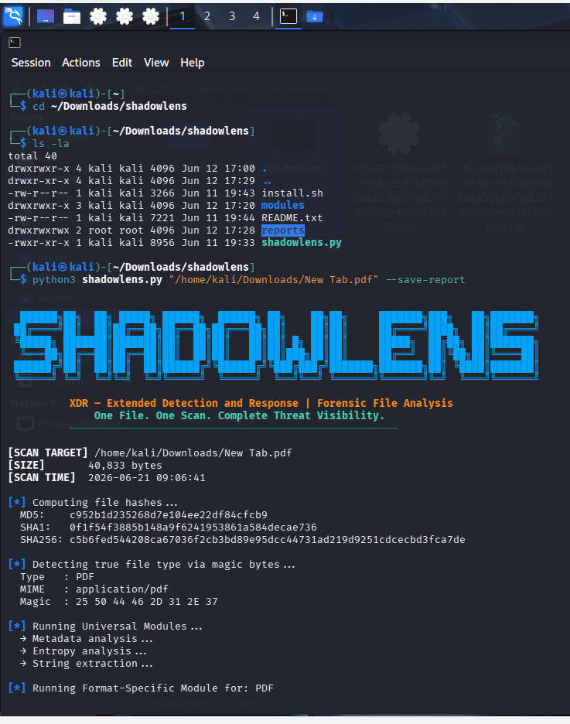

Step 2 Observing the live risk score and entropy findings.
As the scan continued through the Obfuscation and Phishing detection stages, it reported that no URLs were found in the file (correctly skipping the URL Reputation Engine, since there was nothing to check), and then calculated the final risk score.
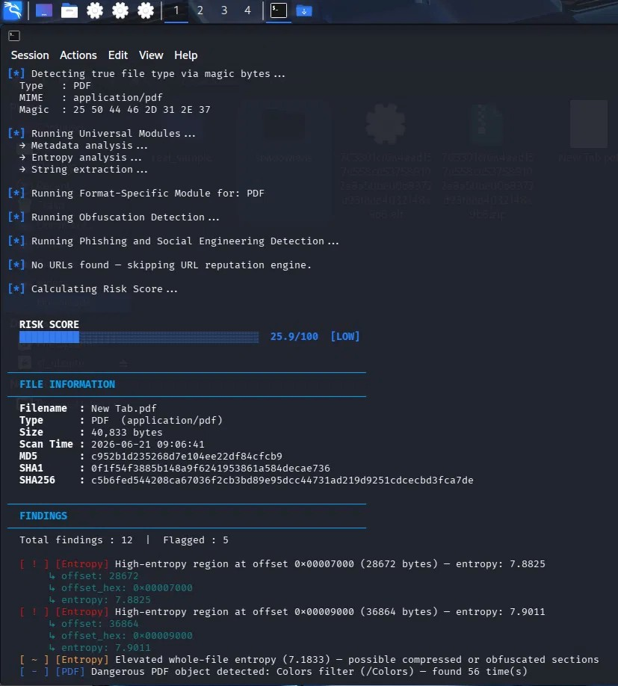
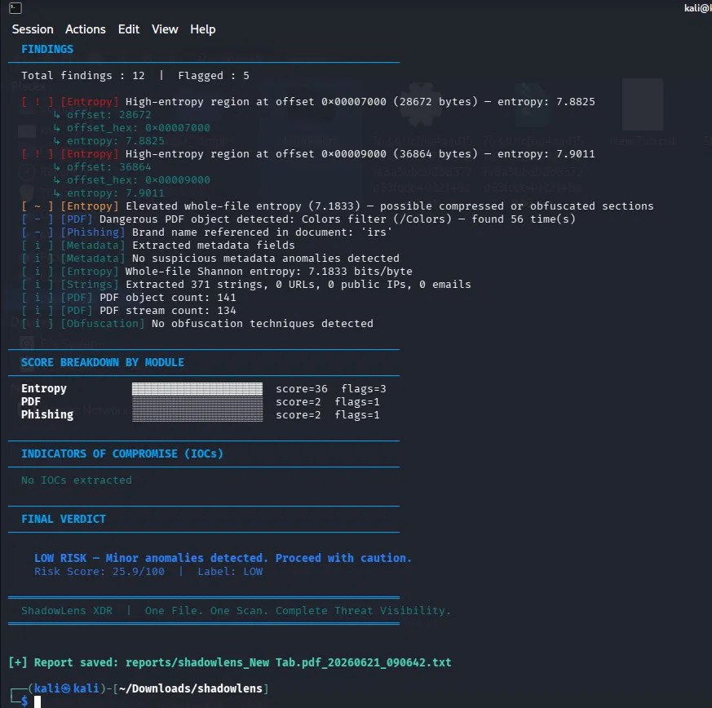
Step 3 : Reviewing the complete findings, score breakdown, and final verdict.
The remaining findings, the per-module score breakdown, the IOC (Indicators of Compromise) section, and the tool's final verdict were then displayed, followed by confirmation that the report had been written to disk.

Analysis: This test confirmed that ShadowLens XDR correctly classifies an everyday, harmless PDF as LOW risk rather than over-flagging it. The two high-entropy regions (7.88 and 7.90 bits/byte) and the repeated /Colors filter object are normal, expected structural characteristics of PDF files they come from routine internal image and font compression, not from hidden malicious payloads and the scoring engine weighted them appropriately as LOW/MEDIUM severity rather than letting them inflate the score into a misleading HIGH or CRITICAL range. The complete absence of IOCs (no URLs, IPs, or emails) further reinforced that this was correctly identified as a clean, low-risk document. This test validated that the Metadata, Entropy, String Extraction, PDF, Obfuscation, and Phishing modules all executed successfully end-to-end on a real file, and that the risk-scoring engine produces sensible, proportionate results on benign input.

8.2 Test 2 : Real Malware Sample (MalwareBazaar)
The second test was designed to validate the tool against an actual, real-world threat rather than synthetic or everyday data. A genuine malware sample was obtained from MalwareBazaar (abuse.ch), a legitimate, research-oriented malware repository used by security professionals and students worldwide for controlled, defensive analysis.
Source: https://bazaar.abuse.ch/browse/
Method used to obtain and scan the sample:
bash
# 1. Download a sample ZIP from MalwareBazaar (browser)
# 2. Extract using the standard MalwareBazaar password "infected"
7z x 763301cf6a4aad157d558cd537589102a8a50be00b8372d93fdde4032148a9b6.zip -pinfected

# 3. Scan the extracted file with ShadowLens XDR
cd ~/Downloads/shadowlens
python3 shadowlens.py "/home/kali/Downloads/763301cf6a4aad157d558cd537589102a8a50be00b8372d93fdde4032148a9b6.elf" --save-report
Step 1 : File type detection and risk score appearing immediately.
As soon as the scan began, the tool computed the file's hashes, correctly identified it as an ELF (Linux executable) binary purely from its magic bytes despite the filename giving no extension hint of being executable and proceeded through every detection module.
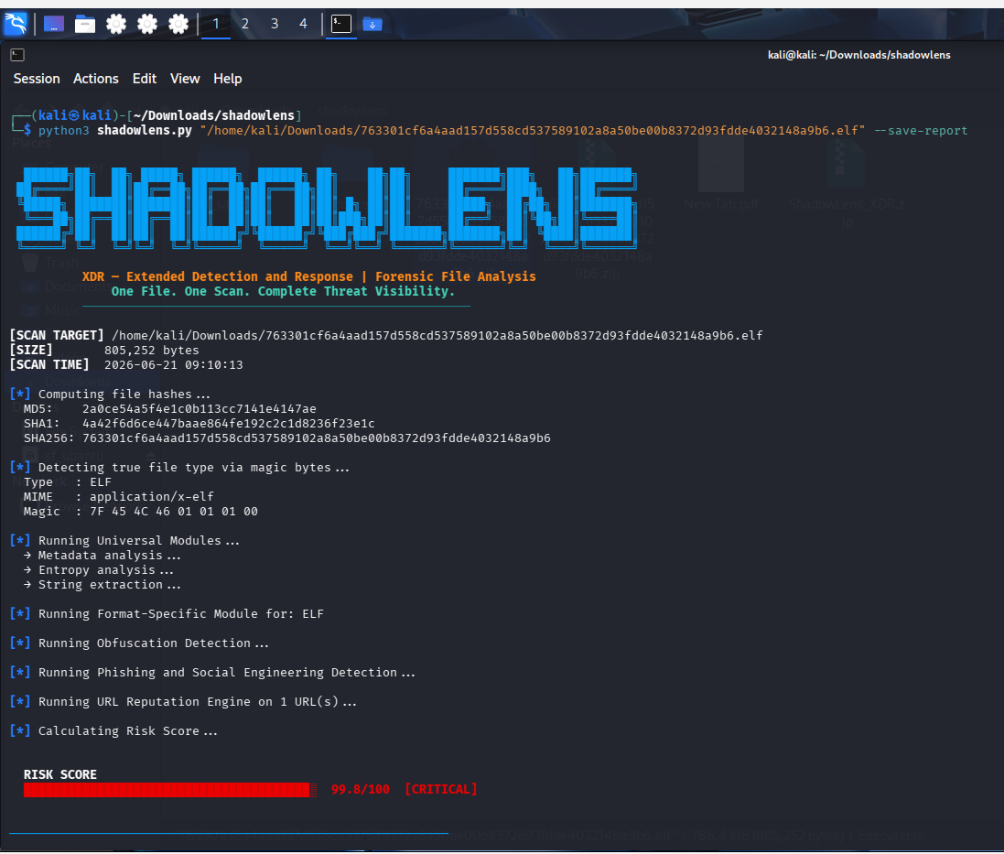
Step 2
Detailed findings showing real threat indicators.
The findings list that followed contained genuine, concrete evidence of malicious capability extracted directly from the binary's internal strings something that would normally require manually running the Linux strings command and then separately cross-referencing each result.
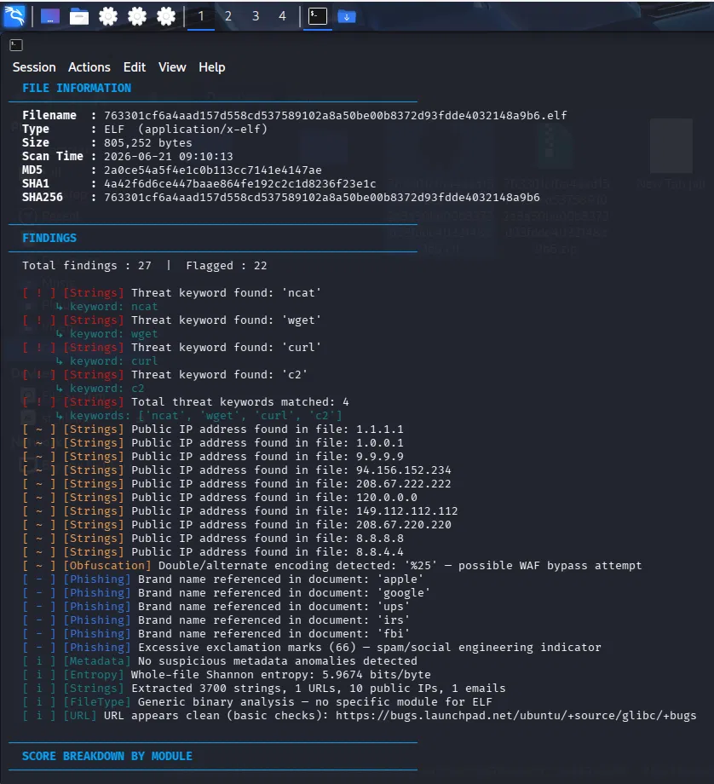
Step 3
Score breakdown, complete IOC list, and final critical verdict.
The scan concluded with a full breakdown of which modules contributed most to the score, a complete list of every Indicator of Compromise extracted from the binary, and an unambiguous final verdict instructing the analyst not to open the file.
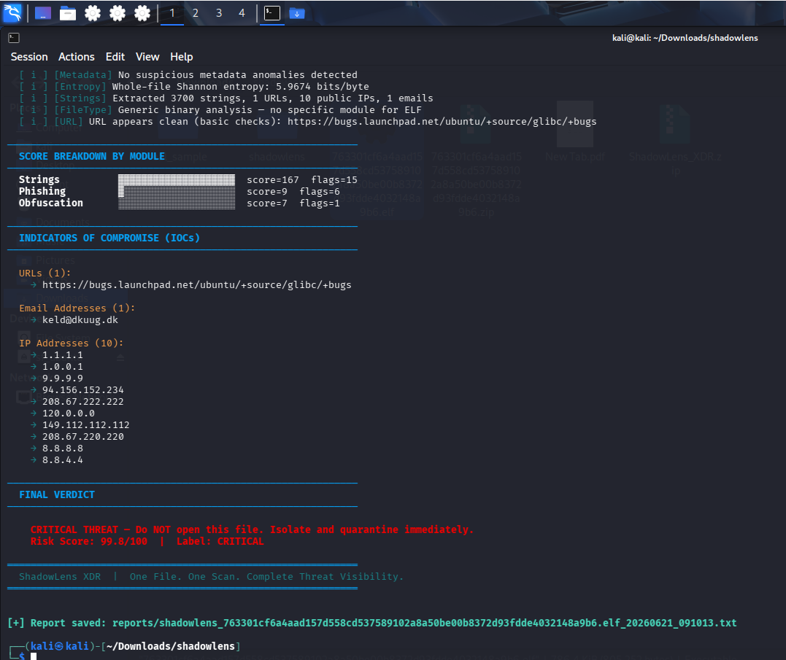

Analysis: This test confirmed ShadowLens XDR's ability to correctly identify a genuinely dangerous file and assign it the highest possible risk classification. Notably, the binary was correctly identified as an ELF executable purely through magic-byte analysis, and even though no dedicated, format-specific analysis module exists for ELF files in this version of the tool, the three universal modules String Extraction, Phishing Detection, and Obfuscation Detection were entirely sufficient on their own to correctly escalate the file to CRITICAL. The presence of ncat, wget, curl, and c2 together inside a single Linux binary is a strong, realistic indicator of remote command-and-control or backdoor capability, since these are exactly the tools and terminology associated with establishing outbound network connections and remote shell access. Combined with ten extracted IP addresses and a live URL, this gave the analyst a concrete, evidence-backed IOC list suitable for direct use in an incident report, rather than a vague "this file is suspicious" judgment with no supporting detail.
Safety note: Throughout this test, the malware binary was only scanned and inspected by ShadowLens XDR it was never executed at any point and the entire process was confined to an isolated virtual machine running in Oracle VirtualBox, consistent with standard, mandatory defensive security research practice when handling real malware samples.

9. RESULTS SUMMARY TABLE
Test | File Type | Method | Risk Score | Label
Test 1 | PDF (synthetic, benign) | Self-created PDF ("New Tab" screenshot) | 25.9 / 100 | LOW
Test 2 | ELF (real malware) | MalwareBazaar sample | 99.8 / 100 | CRITICAL
These two tests together demonstrate that ShadowLens XDR reliably distinguishes between benign and malicious files. On the harmless PDF, the tool correctly avoided over-flagging normal structural characteristics like compressed image streams, producing a low, proportionate score with zero IOCs extracted. On the real malware sample, the same engine using the identical set of universal detection modules correctly identified concrete evidence of network/backdoor capability and escalated the score to 99.8/100 CRITICAL, accompanied by a complete, actionable list of extracted IOCs (one URL, one email address, and ten IP addresses). Together, these results confirm that the tool's risk-scoring engine responds proportionately to the actual evidence present in a file, rather than producing arbitrary or inconsistent results.

